**Practical-3**

1. Write a program to remove duplicate elements of an array.

Code:

using System;

namespace Practical_3

{

class Program

{

static void Main(string[] args)

{

Console.WriteLine("20012011130_Patel Vandan");

int i, j, k, n;

Console.WriteLine("Give the size array:");

n = Convert.ToInt32(Console.ReadLine());

int[] a = new int[n];

Console.WriteLine("Enter the elements:");

for (i = 0; i < n; i++)

{

a[i] = Convert.ToInt32(Console.ReadLine());

}

for (i = 0; i < n; i++)

{

for (j = i + 1; j < n; j++)

{

if (a[i] == a[j])

{

for (k = j; k < n; k++)

{

if (k != n - 1)

a[k] = a[k + 1];

}

n--;

}

}

}

Console.WriteLine("After removal of duplicate elements");

for (int t = 0; t < n; t++)

{

Console.WriteLine(" " + a[t]);

}

}

}

}

Output:

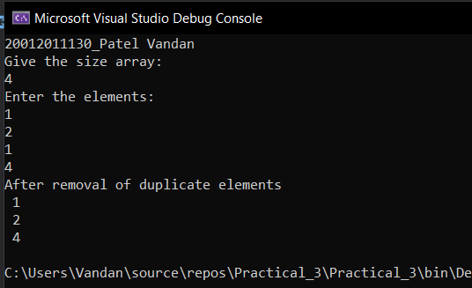

1. Write a program for multiplication of two 2-dimentional matrices using 2-d array.

Program:

using System;

using System.Collections.Generic;

using System.Linq;

using System.Text;

using System.Threading.Tasks;

namespace Practical_3

{

class second

{

static void Main(string[] args)

{

Console.WriteLine("20012011130_Patel Vandan");

Console.WriteLine("Enter number of rows and columns for first 2 - d matrix: ");

int s1 = Convert.ToInt32(Console.ReadLine());

int s2 = Convert.ToInt32(Console.ReadLine());

int[,] a1 = new int[s1, s2];

Console.WriteLine("Enter element of first 2-d matrix:");

for (int i = 0; i < s1; i++)

{

for (int j = 0; j < s2; j++)

{

a1[i, j] = Convert.ToInt32(Console.ReadLine());

}

}

Console.WriteLine("Enter number of rows and columns for second 2 - d matrix: ");

int s3 = Convert.ToInt32(Console.ReadLine());

int s4 = Convert.ToInt32(Console.ReadLine());

int[,] a2 = new int[s3, s4];

Console.WriteLine("Enter element of second 2-d matrix: ");

for (int i = 0; i < s3; i++)

{

for (int j = 0; j < s4; j++)

{

a2[i, j] = Convert.ToInt32(Console.ReadLine());

}

}

Console.WriteLine("Your first 2-d matrix:");

for (int i = 0; i < s1; i++)

{

for (int j = 0; j < s2; j++)

{

Console.Write(a1[i, j] + " ");

}

Console.WriteLine(" ");

}

Console.WriteLine("Your second 2-d matrix:");

for (int i = 0; i < s3; i++)

{

for (int j = 0; j < s4; j++)

{

Console.Write(a2[i, j] + " ");

}

Console.WriteLine(" ");

}

if (s2 == s3)

{

int[,] m = new int[s1, s4];

for (int i = 0; i < s1; i++)

{

int sum = 0;

for (int j = 0; j < s4; j++)

{

for (int k = 0; k < s3; k++)

{

sum = sum + (a1[i, k] * a2[k, j]);

}

m[i, j] = sum;

sum = 0;

}

}

Console.WriteLine("Matrix after multiplication of two matrix: ");

for (int i = 0; i < s1; i++)

{

for (int j = 0; j < s4; j++)

{

Console.Write(m[i, j] + " ");

}

Console.WriteLine(" ");

}

}

else

{

Console.WriteLine("sorry!..Multiplicatio is not possible.");

}

Console.ReadKey();

}

}

}

Output:

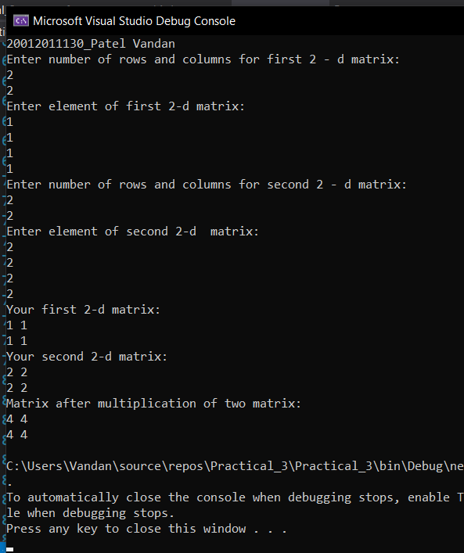

1. Write a program to generate Pascal Triangle using jagged array.

Program:

using System;

using System.Collections.Generic;

using System.Linq;

using System.Text;

using System.Threading.Tasks;

namespace Practical_3

{

class third

{

static void Main(string[] args)

{

Console.WriteLine("20012011130_Patel Vandan");

Console.WriteLine("Enter row value : ");

int num = Convert.ToInt32(Console.ReadLine());

for (int i = 0; i < num; i++)

{

for (int j = num; j > i; j--)

{

Console.Write(" ");

}

int val = 1;

for (int j = 0; j <= i; j++)

{

Console.Write(val + " ");

val = val * (i - j) / (j + 1);

}

Console.WriteLine();

}

Console.ReadLine();

}

}

}

Output:

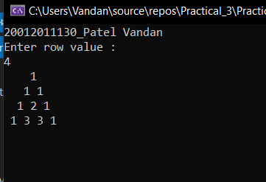

1. Write a user defined function to sort an array.

Program:

using System;

using System.Collections.Generic;

using System.Linq;

using System.Text;

using System.Threading.Tasks;

namespace Practical_3

{

class four

{

static void Main(string[] args)

{

Console.WriteLine("20012011130_Patel Vandan");

int[] arr1 = new int[10];

int n, i, j, tmp;

Console.WriteLine("Input the size of array : ");

n = Convert.ToInt32(Console.ReadLine());

Console.WriteLine("Input {0} elements in the array :", n);

for (i = 0; i < n; i++)

{

Console.WriteLine("element - {0} : ", i);

arr1[i] = Convert.ToInt32(Console.ReadLine());

}

for (i = 0; i < n; i++)

{

for (j = i + 1; j < n; j++)

{

if (arr1[j] < arr1[i])

{

tmp = arr1[i];

arr1[i] = arr1[j];

arr1[j] = tmp;

}

}

}

Console.WriteLine("Elements of array in sorted oder:");

for (i = 0; i < n; i++)

{

Console.WriteLine("{0} ", arr1[i]);

}

Console.WriteLine(" ");

Console.ReadLine();

}

}

}

Output:

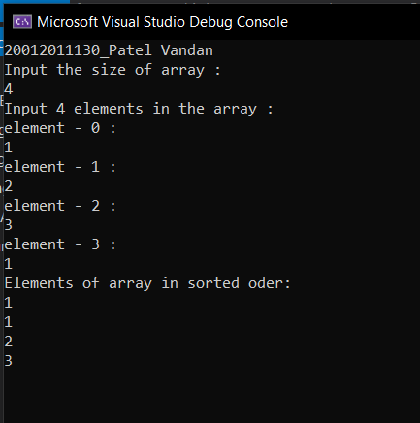

1. Demonstrate the use of params keyword with the help of a program.

Program:

using System;

using System.Collections.Generic;

using System.Linq;

using System.Text;

using System.Threading.Tasks;

namespace Practical_3

{

class Five

{

public static int TotalMarks(params int[] list)

{

int total = 0;

for (int i = 0; i < list.Length; i++)

total += list[i];

return total;

}

public static string AllSubjects(params string[] subjects)

{

System.Text.StringBuilder builder = new

System.Text.StringBuilder();

for (int i = 0; i < subjects.Length; i++)

{

builder.Append(subjects[i]);

builder.Append(" ");

}

return builder.ToString();

}

}

class class4

{

static void Main(string[] args)

{

Console.WriteLine("20012011130_Patel Vandan\n");

Console.WriteLine("Params with 3 parameters");

int total3 = Five.TotalMarks(8, 9, 8);

Console.WriteLine(total3);

string[] subs = { "English", "Reading", "Writing" };

Console.WriteLine(Five.AllSubjects(subs));

Console.WriteLine("Params with 4 parameters");

int[] marks = { 24, 22, 25, 21 };

int total4 = Five.TotalMarks(marks);

string str4 = Five.AllSubjects("Math", "English",

"Art", "Social Science");

Console.WriteLine(total4);

Console.WriteLine(str4.ToString());

Console.WriteLine("Params with 5 parameters");

int total5 = Five.TotalMarks(92, 90, 95, 91, 98);

string str5 = Five.AllSubjects(new string[]{"Math", "English", "Art", "Social Science", "Gym" });

Console.WriteLine(total5);

Console.WriteLine(str5.ToString());

Console.ReadKey();

}

}

}

Output:

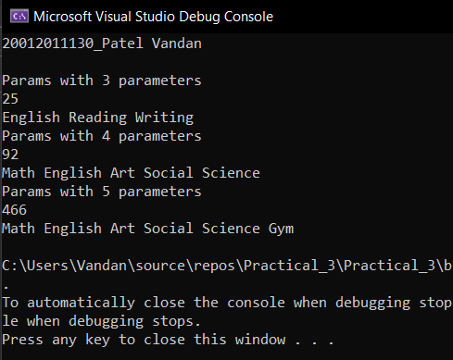

1. Discuss out and ref parameters with the help of programs.

Program:

using System;

using System.Collections.Generic;

using System.Linq;

using System.Text;

using System.Threading.Tasks;

namespace Practical_3

{

class six

{

static void SomeFunction(int[] ints, int i)

{

ints[0] = 100;

i = 100;

}

static void RefFunction(int[] ints, ref int i)

{

ints[0] = 100;

i = 100;

}

static void OutFunction(out int x)

{

x = 200;

}

static void Main()

{

int i = 0;

int[] ints = { 0, 1, 2, 4, 8 };

Console.WriteLine("20012011130_Patel Vandan\n");

Console.WriteLine("Before calling SomeFunction: i = "+i+"and ints[0] = "+ints[0]);

SomeFunction(ints, i);

Console.WriteLine("After calling SomeFunction:i="

+ i + "and ints[0]=" + ints[0]);

RefFunction(ints, ref i);

Console.WriteLine("After calling RefFunction:i=" +

i + "and ints[0]=" + ints[0]);

int x;

OutFunction(out x);

Console.WriteLine("After calling OutFunction x is:" + x);

}

}

}

Output:

